# React Native

# Install react in windows

## Install VS Code IDE

VS Code : - <https://code.visualstudio.com/download>

1. Install extension for react native

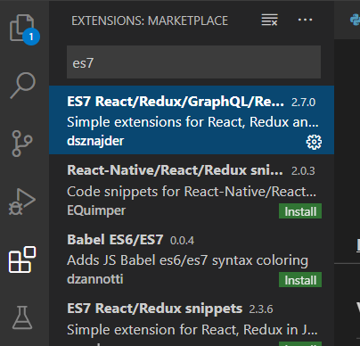

## Install NodeJS and NPM

Download :- <https://nodejs.org/en/>

## Create React APP

### Check version

Open terminal and type:

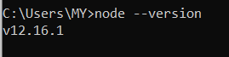

### Install React from terminal:

1. Change current working directory to project directory.

cd D:

1. Create a project directory for react app

mkdir REACT

1. Move to REACT folder

cd REACT

1. Install React from terminal:

npm install -g create-react-app

If successful, you should be able to get version:

create-react-app --version

1. Create react project:

create-react-app <projectname>

Example – This step may take 5 -15 minutes

D:\REACT>create-react-app workout

Creating a new React app in D:\REACT\workout.

Installing packages. This might take a couple of minutes.

Installing react, react-dom, and react-scripts with cra-template...

> core-js@2.6.11 postinstall D:\REACT\workout\node_modules\babel-runtime\node_modules\core-js

> node -e "try{require('./postinstall')}catch(e){}"

> core-js@3.6.4 postinstall D:\REACT\workout\node_modules\core-js

> node -e "try{require('./postinstall')}catch(e){}"

> core-js-pure@3.6.4 postinstall D:\REACT\workout\node_modules\core-js-pure

> node -e "try{require('./postinstall')}catch(e){}"

+ cra-template@1.0.3

+ react@16.13.1

+ react-scripts@3.4.1

+ react-dom@16.13.1

added 1574 packages from 750 contributors and audited 930020 packages in 384.891s

54 packages are looking for funding

  run `npm fund` for details

found 2 low severity vulnerabilities

  run `npm audit fix` to fix them, or `npm audit` for details

Git repo not initialized Error: Command failed: git --version

    at checkExecSyncError (child_process.js:630:11)

    at execSync (child_process.js:666:15)

    at tryGitInit (D:\REACT\workout\node_modules\react-scripts\scripts\init.js:46:5)

    at module.exports (D:\REACT\workout\node_modules\react-scripts\scripts\init.js:266:7)

    at [eval]:3:14

    at Script.runInThisContext (vm.js:120:20)

    at Object.runInThisContext (vm.js:311:38)

    at Object.<anonymous> ([eval]-wrapper:10:26)

    at Module._compile (internal/modules/cjs/loader.js:1158:30)

    at evalScript (internal/process/execution.js:94:25) {

  status: 1,

  signal: null,

  output: [ null, null, null ],

  pid: 1648,

  stdout: null,

  stderr: null

}

Installing template dependencies using npm...

npm WARN tsutils@3.17.1 requires a peer of typescript@>=2.8.0 || >= 3.2.0-dev || >= 3.3.0-dev || >= 3.4.0-dev || >= 3.5.0-dev || >= 3.6.0-dev || >= 3.6.0-beta || >= 3.7.0-dev || >= 3.7.0-beta but none is installed. You must install peer dependencies yourself.

npm WARN optional SKIPPING OPTIONAL DEPENDENCY: fsevents@2.1.2 (node_modules\fsevents):

npm WARN notsup SKIPPING OPTIONAL DEPENDENCY: Unsupported platform for fsevents@2.1.2: wanted {"os":"darwin","arch":"any"} (current: {"os":"win32","arch":"x64"})

npm WARN optional SKIPPING OPTIONAL DEPENDENCY: fsevents@1.2.12 (node_modules\webpack-dev-server\node_modules\fsevents):

npm WARN notsup SKIPPING OPTIONAL DEPENDENCY: Unsupported platform for fsevents@1.2.12: wanted {"os":"darwin","arch":"any"} (current: {"os":"win32","arch":"x64"})

npm WARN optional SKIPPING OPTIONAL DEPENDENCY: fsevents@1.2.12 (node_modules\watchpack\node_modules\fsevents):

npm WARN notsup SKIPPING OPTIONAL DEPENDENCY: Unsupported platform for fsevents@1.2.12: wanted {"os":"darwin","arch":"any"} (current: {"os":"win32","arch":"x64"})

npm WARN optional SKIPPING OPTIONAL DEPENDENCY: fsevents@1.2.12 (node_modules\jest-haste-map\node_modules\fsevents):

npm WARN notsup SKIPPING OPTIONAL DEPENDENCY: Unsupported platform for fsevents@1.2.12: wanted {"os":"darwin","arch":"any"} (current: {"os":"win32","arch":"x64"})

+ @testing-library/jest-dom@4.2.4

+ @testing-library/react@9.5.0

+ @testing-library/user-event@7.2.1

added 36 packages from 54 contributors and audited 930226 packages in 36.973s

54 packages are looking for funding

  run `npm fund` for details

found 2 low severity vulnerabilities

  run `npm audit fix` to fix them, or `npm audit` for details

Removing template package using npm...

npm WARN tsutils@3.17.1 requires a peer of typescript@>=2.8.0 || >= 3.2.0-dev || >= 3.3.0-dev || >= 3.4.0-dev || >= 3.5.0-dev || >= 3.6.0-dev || >= 3.6.0-beta || >= 3.7.0-dev || >= 3.7.0-beta but none is installed. You must install peer dependencies yourself.

npm WARN optional SKIPPING OPTIONAL DEPENDENCY: fsevents@2.1.2 (node_modules\fsevents):

npm WARN notsup SKIPPING OPTIONAL DEPENDENCY: Unsupported platform for fsevents@2.1.2: wanted {"os":"darwin","arch":"any"} (current: {"os":"win32","arch":"x64"})

npm WARN optional SKIPPING OPTIONAL DEPENDENCY: fsevents@1.2.12 (node_modules\webpack-dev-server\node_modules\fsevents):

npm WARN notsup SKIPPING OPTIONAL DEPENDENCY: Unsupported platform for fsevents@1.2.12: wanted {"os":"darwin","arch":"any"} (current: {"os":"win32","arch":"x64"})

npm WARN optional SKIPPING OPTIONAL DEPENDENCY: fsevents@1.2.12 (node_modules\watchpack\node_modules\fsevents):

npm WARN notsup SKIPPING OPTIONAL DEPENDENCY: Unsupported platform for fsevents@1.2.12: wanted {"os":"darwin","arch":"any"} (current: {"os":"win32","arch":"x64"})

npm WARN optional SKIPPING OPTIONAL DEPENDENCY: fsevents@1.2.12 (node_modules\jest-haste-map\node_modules\fsevents):

npm WARN notsup SKIPPING OPTIONAL DEPENDENCY: Unsupported platform for fsevents@1.2.12: wanted {"os":"darwin","arch":"any"} (current: {"os":"win32","arch":"x64"})

removed 1 package and audited 930225 packages in 12.015s

54 packages are looking for funding

  run `npm fund` for details

found 2 low severity vulnerabilities

  run `npm audit fix` to fix them, or `npm audit` for details

Success! Created workout at D:\REACT\workout

Inside that directory, you can run several commands:

  npm start

    Starts the development server.

  npm run build

    Bundles the app into static files for production.

  npm test

    Starts the test runner.

  npm run eject

    Removes this tool and copies build dependencies, configuration files

    and scripts into the app directory. If you do this, you can’t go back!

We suggest that you begin by typing:

  cd workout

  npm start

Happy hacking!

1. Run project:

cd <projectname>

npm start

Expected output in terminal (and should auto open browser to port 3000):

Compiled successfully!

You can now view <project_name> in the browser.

  Local:            http://localhost:3000/

  On Your Network:  http://<your_ip_address>:3000/

Note that the development build is not optimized.

To create a production build, use yarn build.

# Create Hello World app in react

Now the project is created in the following directory,

Location:- D:\REACT\workout

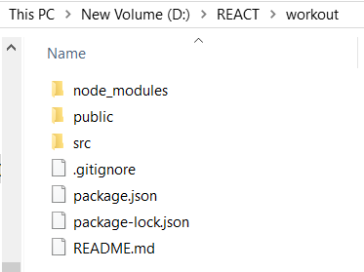

1. Open VS Code

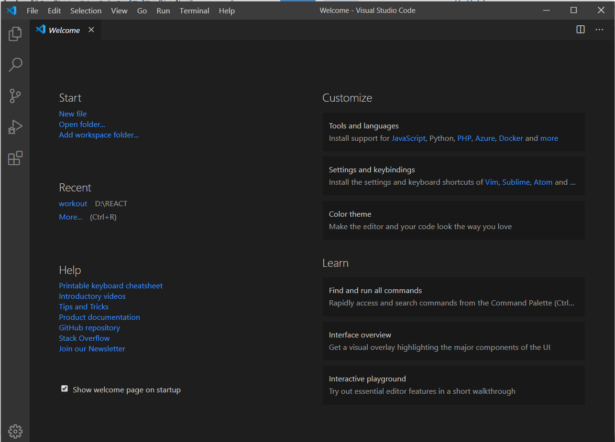

1. Click first option in the left side corner

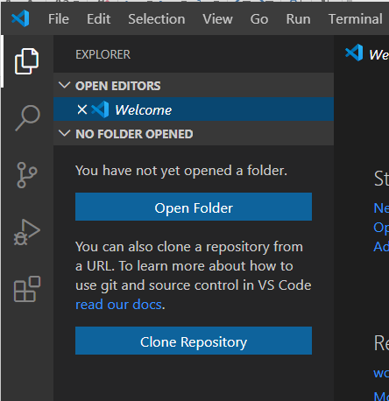

1. Click open folder option
2. Select your project folder

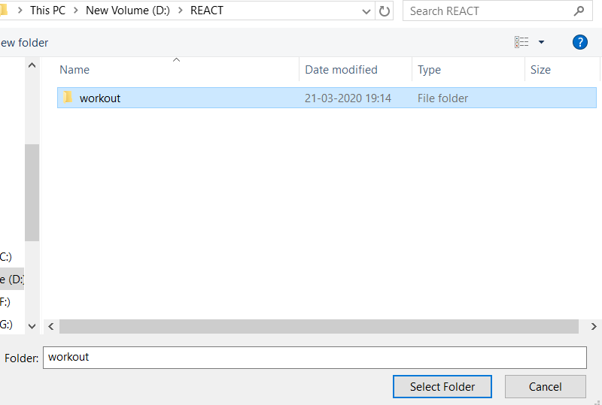

1. Open “src”

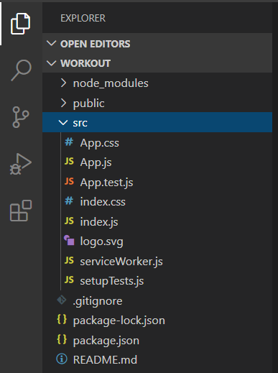

1. Click “App.js” & Edit the component inside <header> tag

You can refer the following code

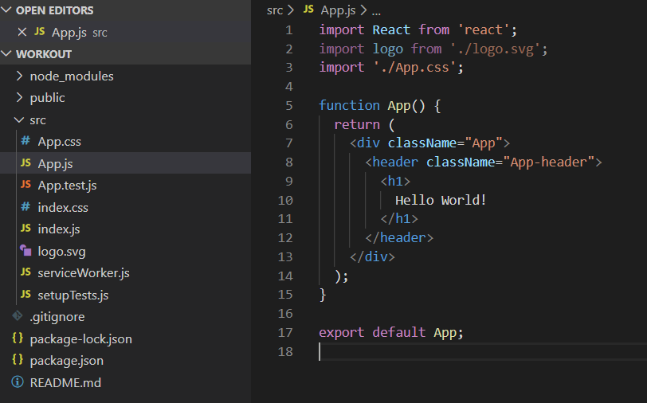

# install react in android studio - not working

1. Install node js (if already installed skip this step)
2. Install android studio

<https://developer.android.com/studio>

# React for android app – not working

1. Install chocolate in windows
   1. Open windows powershell in administrative mode
   2. Copy and paste the following code

Set-ExecutionPolicy Bypass -Scope Process -Force; [System.Net.ServicePointManager]::SecurityProtocol = [System.Net.ServicePointManager]::SecurityProtocol -bor 3072; iex ((New-Object System.Net.WebClient).DownloadString('https://chocolatey.org/install.ps1'))

* 1. Wait a few seconds for the command to complete.
  2. If you don't see any errors, you are ready to use Chocolatey! Type choco or choco -?

1. Change current working directory to project directory
   1. In poershell > cd D:
   2. cd REACT\
   3. make a new directory for android apps> mkdir android
   4. cd android
2. React Native also requires a recent version of the Java SE Development Kit (JDK), as well as Python 2. Both can be installed using Chocolatey.
   1. In powershell > choco install -y nodejs.install python2 jdk8

# Create android app in react

1. Open cmd and run the following code – this step takes (30 min – 1 hr)

npm install -g expo-cli

1. Change current working directory to project directory
   1. In poershell > cd D:
   2. cd REACT\
   3. make a new directory for android apps> mkdir android
   4. cd android
2. Then run the following commands to create a new React Native project called "AwesomeProject": (time: 5 – 10min)

expo init AwesomeProject

cd AwesomeProject

1. To open project in vs code run the command in cmd

code .

1. To start react project. Run this code in cmd

npm start # you can also use: expo start

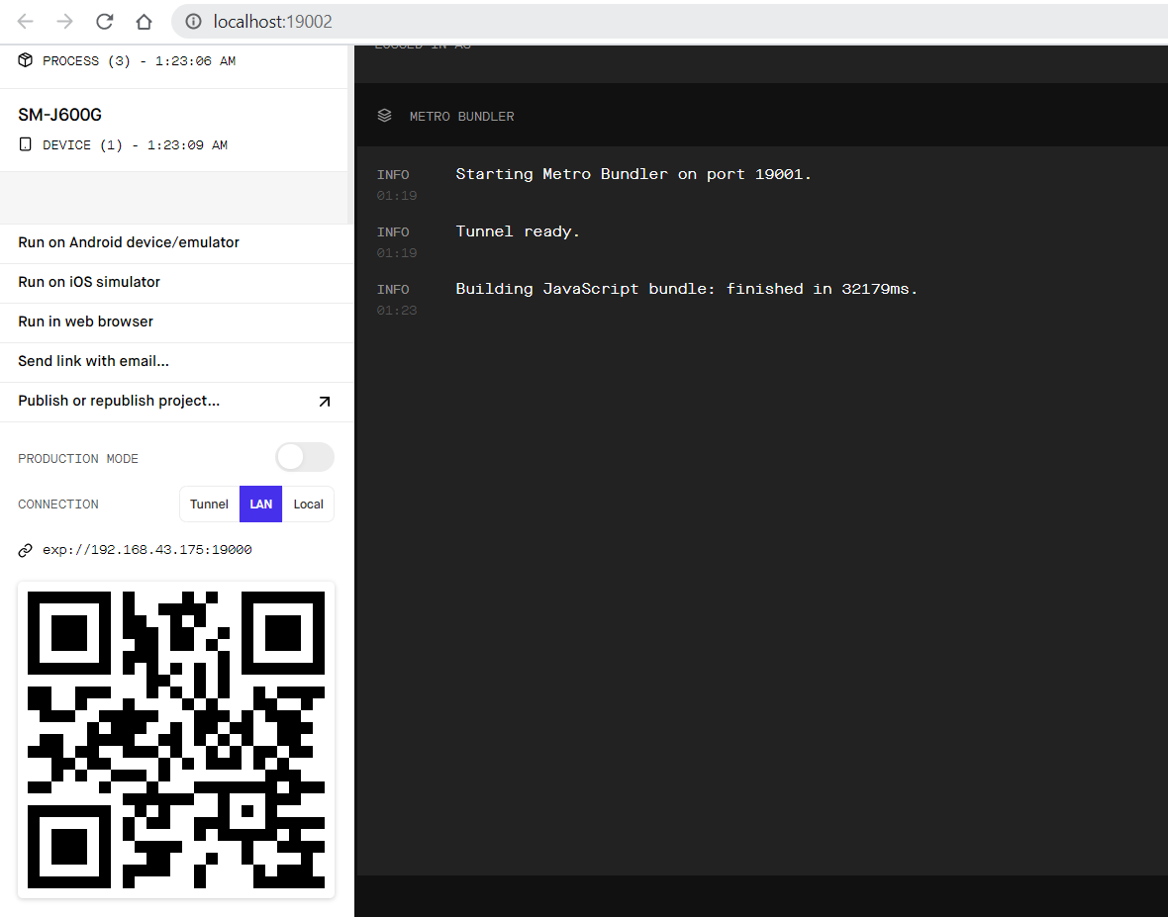

1. Download “Expo” app from android play store

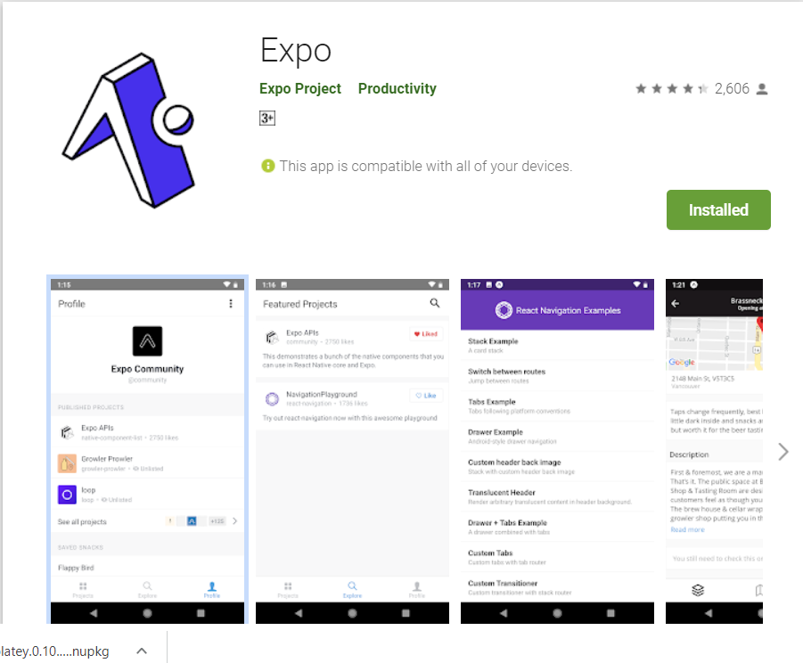

1. Mobile phone and computer should be in same network
2. Scan QR code

